Code Crawler
Design

Version 2.1

Revision History
Date | Version | Description | Author
12/08/2004 | 1.0 | Initial entry | Mohan Kishore
12/11/2004 | 1.1 | Revision | Mohan Kishore
11/8/2026 | 2.0 | Formatted to follow template. Integrated designs for other packages | Nikolay Kojuharov
4/29/05 | 2.1 | Updated for final report | Kinis Meyer

Table of Contents
1. CodeBank 4
2. Code Analysis 5
3. Indexing 6
3.1 Monitor 6
3.2 Swapping the Index 8
3.3 Term Mangling 8
3.4 Word Breaking 9
4. Search 9
4.1 Query Parser 9
4.2 Query Syntax 9
4.3 Ranking Search Results 10
5. Formatting 12
6. Util 12

Software Requirements Specification

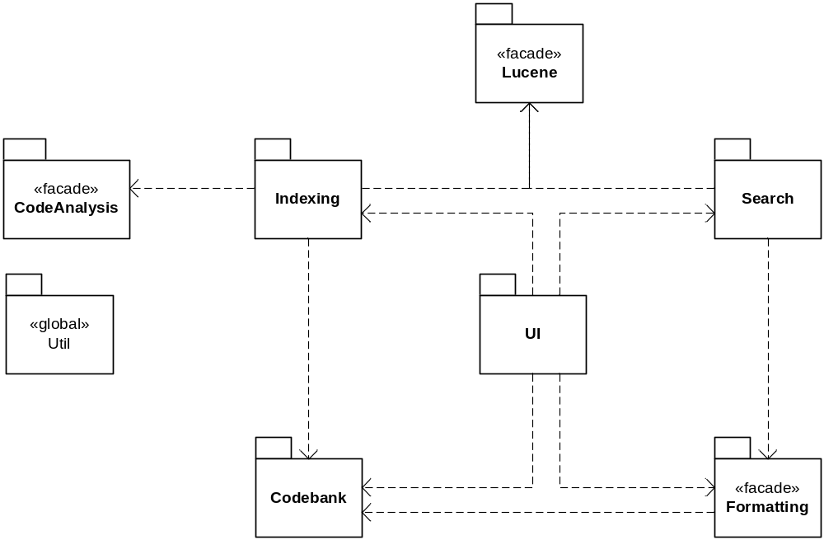
Figure 1. Overall package diagram.

CodeBank
The Workspace class will be a singleton that will manage the codebanks as a list of files on the local hard disk. It will keep a mapping between <Codebank name, filename> tuple and a File object. For each file object it will keep a reference count so it will know when a file is being used. To avoid running out of disk space, it will also keep a history of when files were added and will delete the ones that were added first (moved to version 1.1 implementation).

Codebank instances for remote locations and for archive files will download/unarchive files and will add them to the workspace so later accesses to these files can be fast.

CodebankIterators will keep track of the Codebank which created them. They will obtain a list of files from the Codebank and iterate through them. For recursive iteration, if a directory is encountered, the iterator will obtain a new Codebank for the sub-directory. It will then get the iterator of the new Codebank, put it on its stack, and use it to iterate over the files of the sub-directory. When this iteration is done, it will remove the iterator from the stack and continue. For archives, it will be the same way as with subdirectories; the iterator will create a temporary codebank directory and use its iterator to iterate over the files of the archive.

To improve performance, we may consider starting multiple file fetches on different threads, to decrease the fetch latency (moved to version 1.1 implementation).

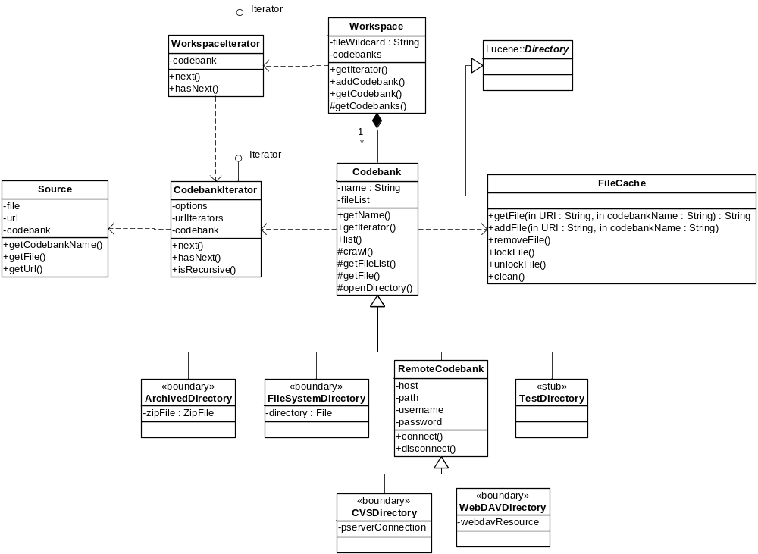
Figure 2. Class diagram for the Codebank package

FileCache was deleted and the necessary responsibilities were relocated under the workspace class. The TestDirectory was removed and a temporary codebank directory was added for archived codebanks for iterating over and indexing purposes.

Code Analysis
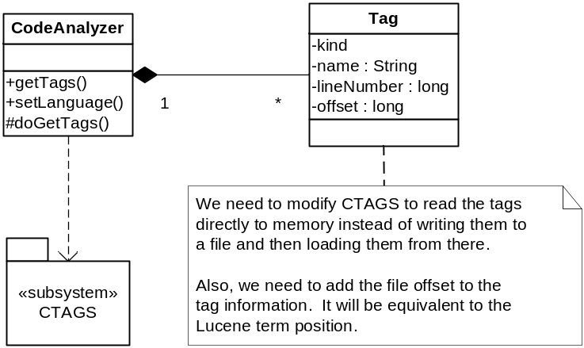
Figure 3. Class diagram for the CodeAnalysis package

CTAGS currently can only read from a file or from a standard C input stream and outputs the tags to a file or to the C standard output. Then the tag reading code reads the tags from a file. We should tweak the code to redirect the standard C input and output streams to Java InputStream and OutputStream to avoid reading and writing to/from a file. We should also skip the step of writing the tags to a file and then reading them from it.

Indexing
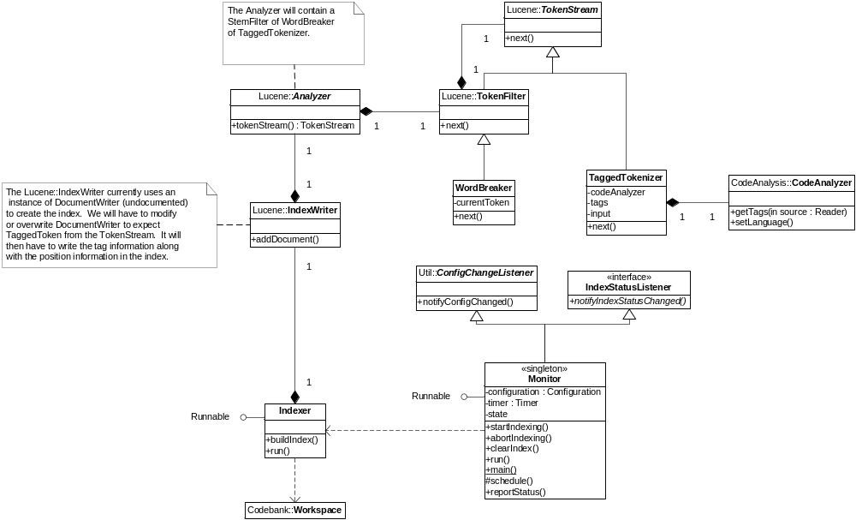
Figure 4. Class diagram for the Indexing package

Monitor
The Monitor it a singleton class representing the main object monitoring the scheduled system events, the indexing process and changes to the configuration affecting that process.
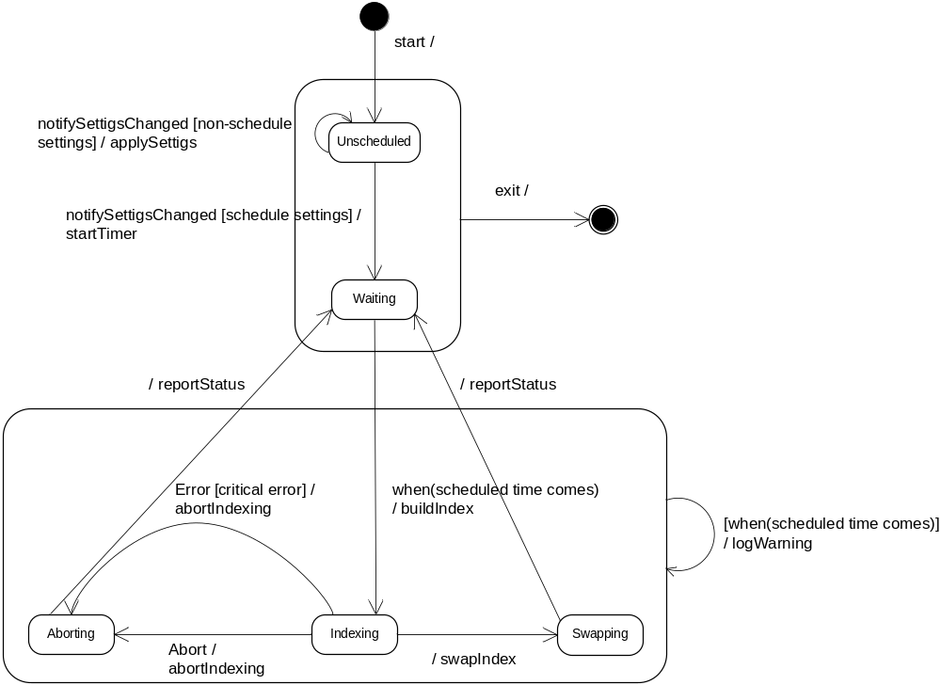
Figure 5. State diagram for the Monitor class

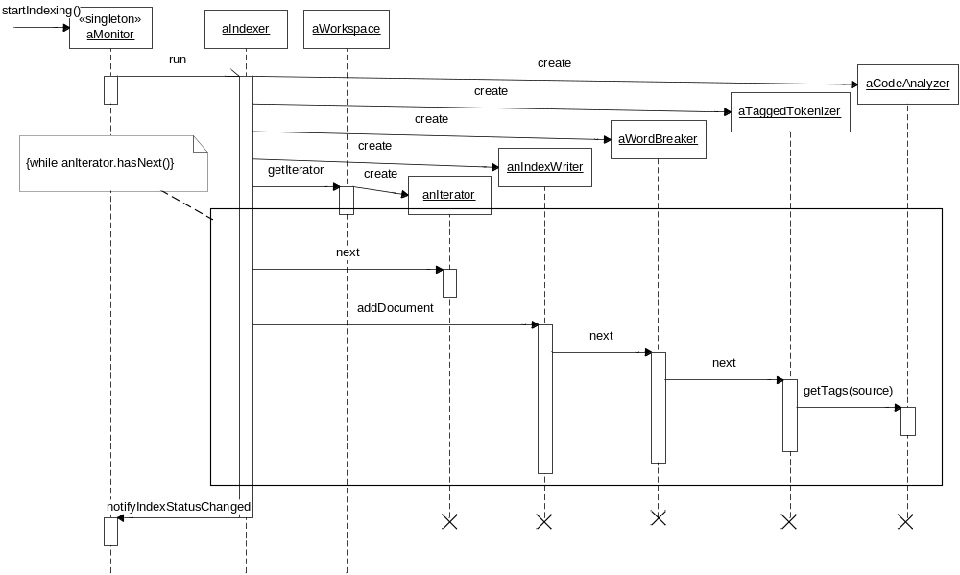
Figure 6. Sequence diagram for building the search index.

The TokenStream chain above will also contain a LowerCaseFilter at the top level (i.e. the LowerCaseFilter contains the WordBreaker filter). It is not shown in the diagram above to avoid cluttering it.

Swapping the Index
When indexing finishes successfully, the newly built index needs to be swapped with the currently stable index. To avoid disrupting any searches that have already started the Indexer should delay the deletion of the stable index until all searches that use it have finished. However, new searches should use the newly build index. To make this work the swapping algorithm should look like this:

proc SwapIndex
change the stable index location in the configuration singleton to point to the newly build index (the stable index becomes deprecated, the new index becomes stable)
while the reference count on the deprecated index is not zero
sleep
delete the deprecated index
end

For this to work, every new instance of a Searcher should increase the reference count on the stable index.

Term Mangling
In order to allow relevance ranking to take into account the semantic kind of a term (i.e. class or function) we need to store this information (or tag) in the search index. Since a document may contain several occurrences of a term, each with a different tag (e.g. class Test { int Test; } – here test is a class or a variable) we need to distinguish between the terms with different tags. To do this we will mangle the tag with the term string – for example, “foo@v” and “bar@c” will specify the occurrences of a variable “foo” and a class “bar”. Since the TaggedTokenizer will never produce tokens that contain @, this mangling will be unique.

Word Breaking
To allow finding terms that only partially match the term query (e.g. searching for “iterator” should find “getIterator”), we will add a TokenFilter subclass – WordBreaker. It will break tokens returned by the TaggedTokenizer using the following rules:
- break the token if the letter case changes from lower case to upper case (e.g. getIterator -> get, Iterator)
- break the token at any non-alphanumeric character (e.g. get_iterator -> get, iterator)
In the above rules, token is used to mean the token returned by the TaggedTokenizer without the tag information. The rules will preserve the letter case of the tokens.

Search
The search module consists of two major tasks:
- parsing the search string input by the user into a format understood by the search engine, and
- designing the hooks necessary to indicate the different relevance values user may attach to different kinds of constructs (e.g. classes, functions etc.) – ultimately resulting in ranking of search results.

CodeCrawler uses Lucene as the default search engine. The CTAGS project is used to analyze the source code and extract additional information like function and variable names from the same. This information (e.g. a space-separated list of function names) is then added to the Lucene index along with the text contents of the files. The rest of the document will describe how the various sub-components are leveraged to get the desired functionality.

Query Parser
Lucene ships with an in-built QueryParser class.
(see: http://jakarta.apache.org/lucene/docs/queryparsersyntax.html)

But since this query syntax does not suffice for the CodeCrawler project, we have defined a different grammar for the queries CodeCrawler search will support. We will use JavaCC parser generator tool to develop the appropriate parser. The parser will convert the search string into a Query object.

When comparing the query terms to the ones in the search index, the QueryParser should ignore the term tag (e.g. matching “foo” or “function:foo” with “foo@v” should both succeed). This will return a superset of terms that the query should match, but the ranking algorithm described below would generate low scores for the terms that have an incorrect tag.

Query Syntax
query -> qlist
qlist -> qterm qop qlist | qterm
qterm -> kind = qexpr | date rop date | size rop number | language = language | file = filename
qterm -> word | regex | ( query )
kind -> class | function | variable | parameter
qop = and | or | not
rop -> < | > | <= | >= | =
word -> any word (case insensitive)
date -> any date in mm/dd/yyyy format
number -> any integer number (representing file size in Kilobytes)
language -> any supported language abbreviation (TBD)
filename -> any filename (without spaces or quoted otherwise)

regex = any regular expression

Ranking Search Results
Lucene uses the following scoring algorithm to rank the results, where the score for document d is:

Σ( tf_q * idf_t/norm_q * tf_d * idf_t/norm_d_t * boost_t ) * coord_q_d

Where,
tf_q | the square root of the frequency of t in the query
 | if a term appears multiple times in a query, it is important to the user and results in a higher score
tf_d | the square root of the frequency of t in d
 | if a term appears multiple times in a document, the document is really relevant and results in a higher score
idf_t | log(numDocs/docFreq_t+1) + 1.0
 | A measure of how rarely this term is found in the documents – higher value results in higher score
numDocs | number of documents in index
 | if greater number of documents have been indexed, the relative number of documents containing the term goes down – making the term a good search criteria, resulting in a higher score.
docFreq_t | number of documents containing t
 | if greater number of documents contain this term, the relative number of documents containing the term goes up – making the term a relatively common one (ie. Not a good search criteria), resulting in a lower score.
norm_q | sqrt(sum_t((tf_q*idf_t)^2))
 | A normalizing factor for query terms
norm_d_t | square root of number of tokens in d in the same field as t
 | A normalizing factor for document terms
boost_t | the user-specified boost for term t
 | If the user feels that a particular term is more important than others, he can define a higher boost value for this term – resulting in a higher score.
coord_q_d | number of terms in both query and document / number of terms in query
 | The coordination factor gives an AND-like boost to documents that contain more terms from the query. e.g. all three terms in a three word query over those that contain just two of the words.

Note that the score of each document depends on the sum of each term against that document. This lets us play with the boost values for individual terms to express the relative importance of a “class” as compared to a “function”.

CodeCrawler will maintain two sets of boosts, which can be configured by the user. The two sets will be applied as follows:
- When the user searches for a word/phrase (e.g. “foo”) the default boost values without an associated category will be the following for mandatory categories:
  - LANGUAGE=0.8
  - SIZE=0.5
  - MODIFIED=0.5
  - INDEXED=0.5
  - FILENAME=1.0
  - CONTENTS=0.1

- When the user searches for a word/phrase (e.g. “foo”) the default boost values without an associated category will be the following for optional categories:

  - CLASS=1.0
  - BLOCK DATA=0.5
  - COMMON=0.5
  - COMPONENT=0.5
  - CONSTANT=0.7
  - CURSOR=0.8
  - DEFINE=0.6
  - ENTRY=0.5
  - ENUM=0.5
  - ENUMERATOR=0.5
  - EVENT=0.5
  - EXCEPTION=0.6
  - EXTERNVAR=0.5
  - FEATURE=0.5
  - FIELD=0.7
  - FUNCTION=0.8
  - FUNCTOR=0.5
  - INTERFACE=0.9
  - LABEL=0.5
  - LOCAL=0.5
  - MACRO=0.5
  - MEMBER=0.5
  - METHOD=0.8
  - MIXIN=0.5
  - MODULE=0.9
  - NAMELIST=0.5
  - NAMESPACE=0.5
  - PACKAGE=0.5
  - PROGRAM=1.0
  - PROCEDURE=0.8
  - PROPERTY=0.5
  - PROTOTYPE=0.5
  - RECORD=0.5
  - SIGNATURE=0.5
  - SINGLETON METHOD=0.5
  - STRUCT=0.6
  - STRUCTURE=0.5
  - SUB=0.7
  - SUBROUTINE=0.7
  - SUBTYPE=0.5
  - TABLE=0.8
  - TRIGGER=0.7
  - TYPE=0.5
  - TYPEDEF=0.5
  - UNION=0.5
  - VALUE=0.5
  - VARIABLE=0.7

- When the user searches for word/phrase along with an associated type (e.g. “function:foo”) the boost values will adjust to be similar to the following values:
  - filename=0.5
  - class=0.5
  - function=1.0 (since it was chosen)
  - variable=0.35
  - …

Formatting
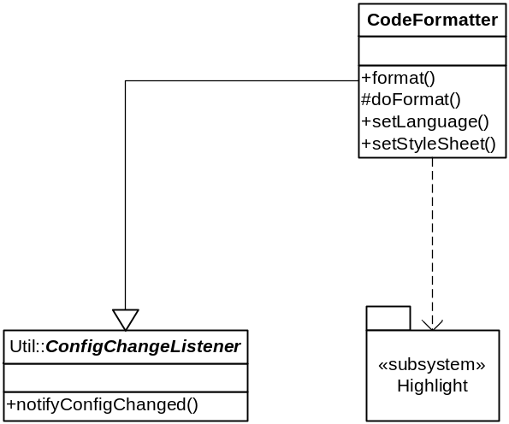
Figure 7. Class diagram for the Formatting package

Currently, formatting is not thread safe, and is statically synchronized.

Util
The Configuration class will contain a static instance which will contain the most up to date configuration. It will also keep a collection of observers, that will be notified when the configuration changes.

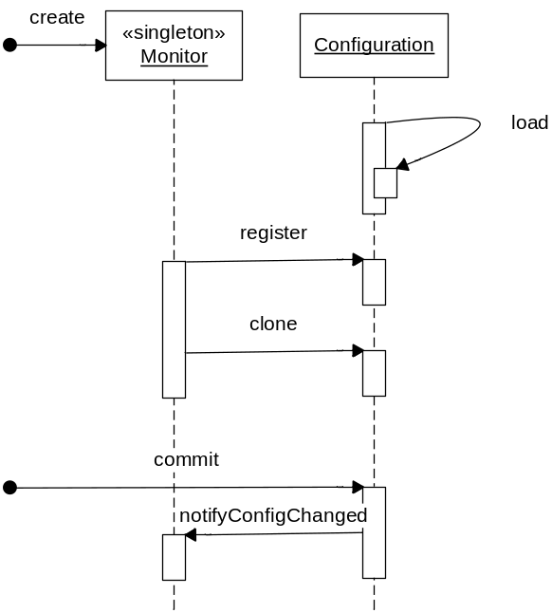
Figure 8. Sequence diagram for registering as ConfigChangeListener and changing the configuration

